

Lab # 01

Fundamentals of Programming
Fall 2024



Instructor | Rozi Khan
Student Name | Muhammmad Taha
CMSID | 518133
Department | CS
Semester | 1st

Lesson Set 1 | Introduction to Computer programming and the process of translation  Tools for Coding and their Installation
Purpose | - To learn the basics of an editor and compiler and be able to compile and run programs  - To understand the process of translation of code from High-Level Language to Machine Language  - To get basic awareness of computer programming  - To become familiar with the tools used for programming and their installation  - To enter code and run a simple program from scratch
Procedure | - Students should read the Pre-lab Reading assignment before coming to the lab.  - Students should complete the Pre-lab Writing assignment before coming to the lab.  - In the lab, students should complete Labs 1.1 through 1.2 in sequence. Your instructor will give further instructions as to grading and completion of the lab.  - Students should complete the set of lab tasks before the next lab and get them checked by their lab instructor.
 | Contents | Pre-requisites | Completion Time | Page Number
 | Pre-lab Reading Assignment | - | 20 min | 3
 | Pre-lab Writing Assignment | Pre-lab Reading | 10 min | 7
 | Lab 1
 | Lab 1.1  Installing Code Editor for C++ | Pre-lab reading | 30 min | 8
 | Lab 1.2  Lab Tasks | Awareness of Syntax Rules | - | 10

PRE-LAB READING ASSIGNMENT
Introduction to Computer Programming
A computer program is a series of instructions written in some computer language that performs a particular task. The language code is frequently the only thing that new students focus on, but great software can only be produced after a rigorous design that identifies the needs, data, method, and anticipated consequences. For this reason, before attempting to create a high-quality program students must master sound design principles. An algorithm, which is a strategy for taking on a problem, directs design. A recipe for a cake, a study plan for an exam, or the specs of a rocket engine are all examples of tasks that require algorithms.
Pseudocode is an artificial and informal language that helps programmers develop algorithms. Pseudocode is a "text-based" detail (algorithmic) design tool. The rules of Pseudocode are reasonably straightforward. All statements showing "dependency" are to be indented. These include while, do, for, if, and switch. The examples below will illustrate this notion.

Problem example: Create an algorithm to find the average of seven paper marks

An algorithm usually begins with a general broad statement of the problem. Find the average of Five Test Grades From here we can further refine the statement by listing commands that will accomplish our goal.

Read in the paper Marks |  | Find the Average |  | Write out the Average

Each box (called a node) may or may not be refined further depending on its clarity to the user. For example: Finding the Average may be as refined as an
Experienced programmer needs to accomplish the task of finding an average; however, students learning how to compute averages for the first time may need more refinement about how to accomplish the goal. This refinement process continues until we have a listing of steps understandable to the user to accomplish the task. For example, Find the Average may be refined into the following two nodes.

Total=sum of 7 paper |  |  | Average=Total/7

Starting from left to right, a node that has no refinement becomes part of the algorithm. The actual algorithm (steps in solving the above program) is listed in bold.

Find the Average of seven paper marks

- Read in the marks
- Find the Average
- Total = sum of 7 papers
- Average = Total / 7
- Write Out the Average
From this algorithm, a program can be written in C++.
Process of Translation | Computers do not understand human languages. In fact, at the lowest level, computers only understand sequences of numbers that represent operational codes (op codes for short). On the other hand, it would be very difficult for humans to write programs in terms of op codes. Therefore, programming languages were invented to make it easier for humans to write computer programs.
Programming languages are for humans to read and understand. The program (source code) must be translated into machine language so that the computer can execute the program (as the computer only understands machine language). The way that this translation occurs depends on whether the programming language is a compiled language or an interpreted language.

Compiled languages (e.g. C, C++)
The following illustrates the programming process for a compiled programming language.
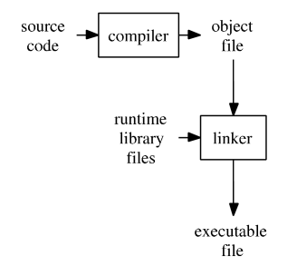
A compiler takes the program code (source code) and converts the source code to a machine language module (called an object file). Another specialized program called a linker, combines this object file with other previously compiled object files (in particular run-time modules) to create an executable file.

Control Structures | All computer programs are written using one or more of three basic control structures: sequence, repetition, and selection. Another term used for control structures is logic structures because they control the logic flow of the program.  While in every program that is written the sequence structure will be used, in almost all programs all three control structures will be used  The Sequence Structure  - The sequence structure directs the computer to process the program instructions, one after another, in the order in which they are listed in the program  - An algorithm is a finite number of step-by-step instructions that accomplish a task  - Example: Making a cup of tea and filling petrol at a petrol pump.  The Selection Structure  - The selection structure directs the computer to make a decision (evaluate a condition), and then take an appropriate action based upon that decision  - The selection structure allows the programmer to evaluate data, therefore properly controlling the logic flow of the program  - Another name for the selection structure is the decision structure  - Example: stopping or going at a signal light  The Repetition Structure  - The repetition structure, commonly called iteration or looping, directs the computer to repeat one or more program instructions until some condition is met  - This condition may be checked at the beginning or end of the set of instructions to be processed dependent upon the language being used  - The repetition structure allows the programmer to repeatedly process a set of instructions, while only typing them in once

Pre-lab writing assignment
Fill in the blanks | - Compilers detect ______syntax __________ errors.  - Usually the most difficult errors to correct are the _____logical___________ errors since they are not detected in the compilation process.  - Attaching other pre-written routines to your program is done by the  ___linking_____________ process.  - _____Binary ___________ code is the machine code consisting of ones and zeroes that is read by the computer.  - Dividing by zero is an example of a ______logical__________ error.

Lab 1

Lab 1.1
Installing IDE for C++
- Installing VS code is very easy. Following are the steps that are to be followed in order to install VS code in a computer system.
  - Download the installer package for VS code or get the package from any other source

Once you get the installer package double click the setup icon

  - On the screen that appears check “I agree to the license terms and conditions” and then click next.
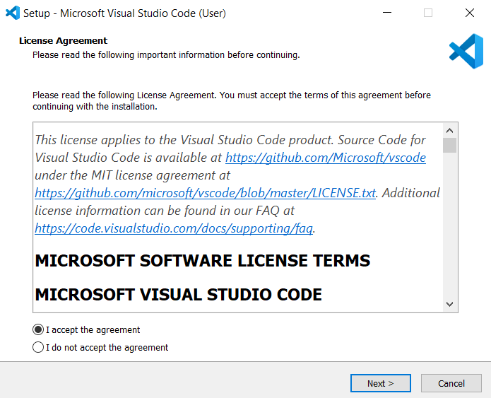

- Select a folder by clicking Browse or just follow the default path.

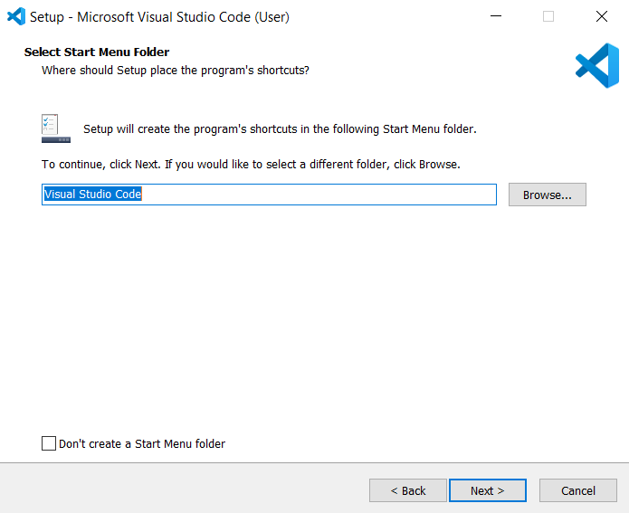

  - Select the require checkbox as per your need
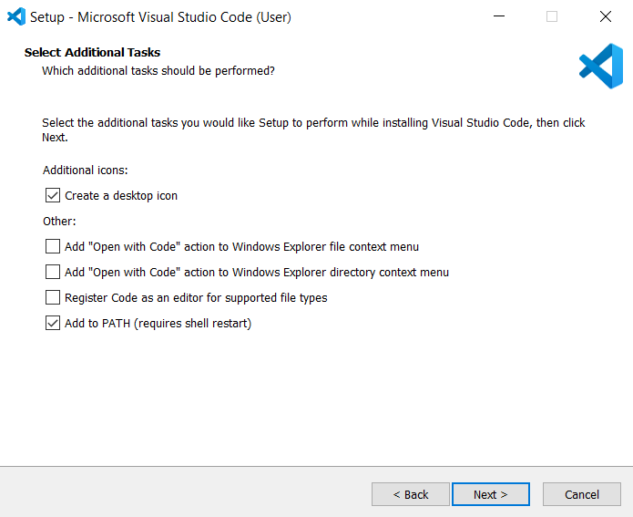

  - VS code is now ready to install and wait for the process and finish.
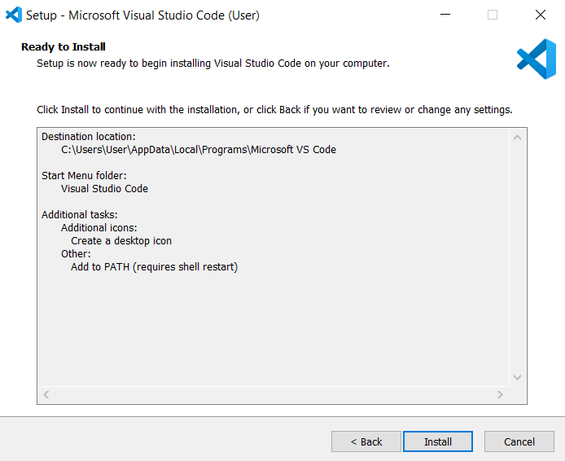
  - VS code is now installed run the application and start coding
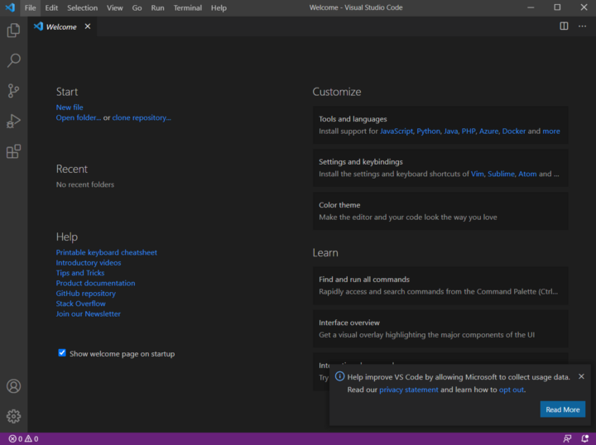
For the C++ compiler install minGW through the link: https://mingw.en.softonic.com/download

Lab 1

Lab 1.1  Installing IDE for C++ | In order to install Dev-C++, we need to first download it. To download Dev-C++ please refer to its Official Website.
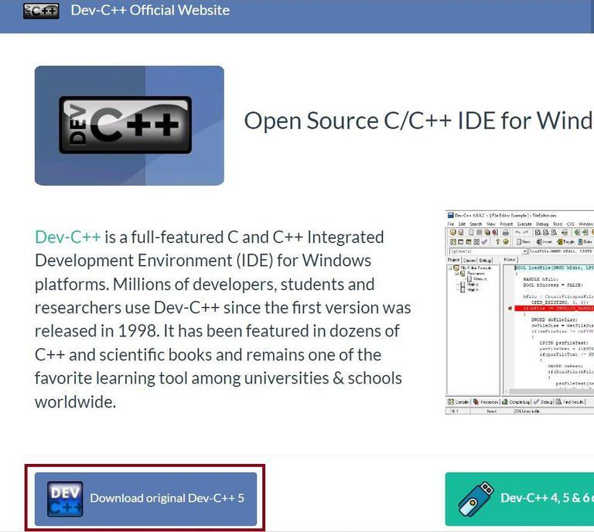
Once we have downloaded the Dev-C++ software. We need to follow the following steps to install it. Below are the steps for the installation,
Step 1: | Getting Started. Click the OK button to start the installation. 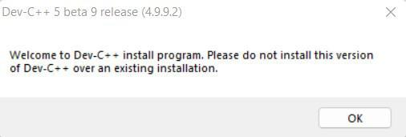
 | Note: Please make, there is no any other version of Dev-C++ is already installed. If any other version of Dev-C++ is already installed then we need to first uninstall it and then install the new version. 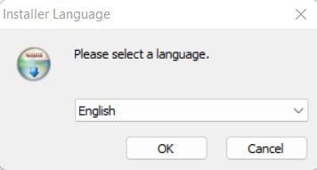
Step 2: | Now, accept the License Terms & Agreement by clicking “I Agree”. 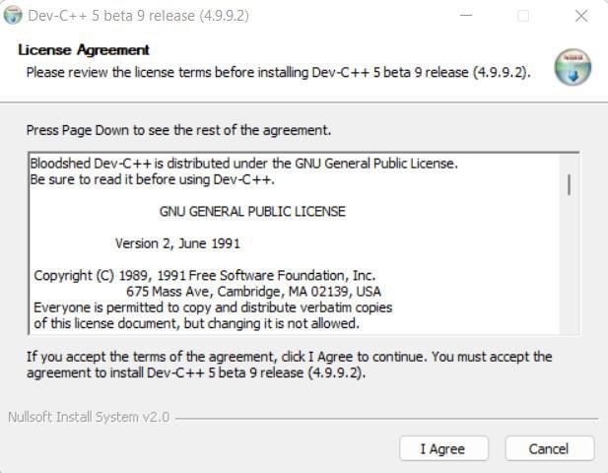
Step 3: | Choosing Components To Be Installed. 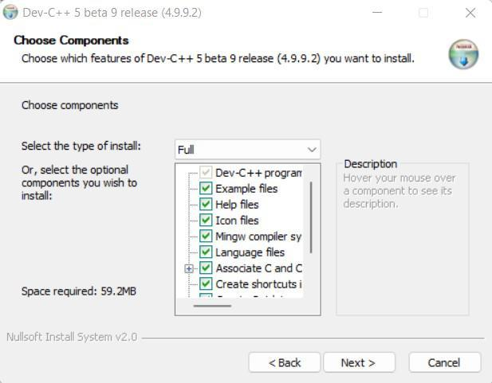
Step 4: | Specify the Location. 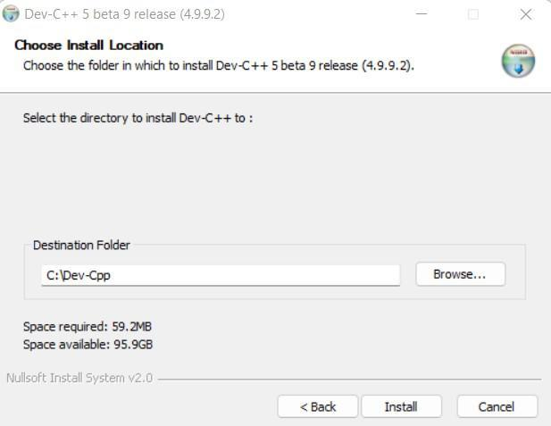
Step 5: | Installing Libraries. 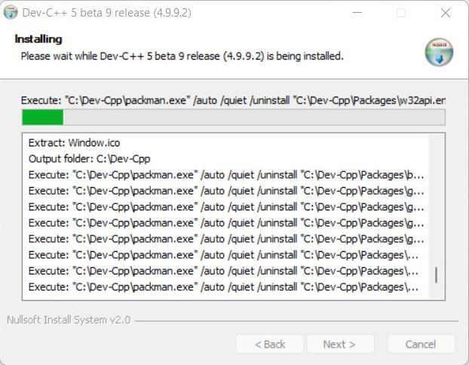
Step 6: | Installation Completion. 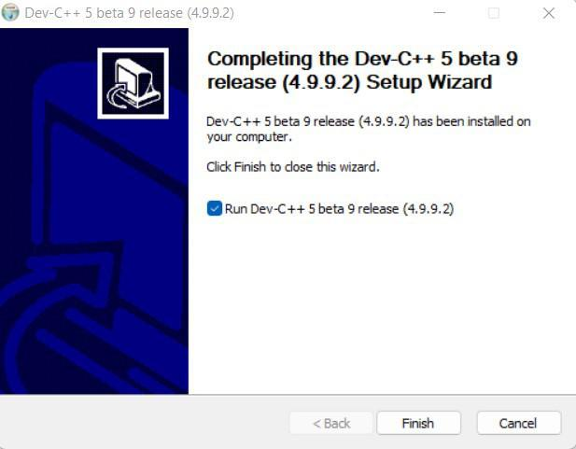
Step 7: | Define Path & Directories. 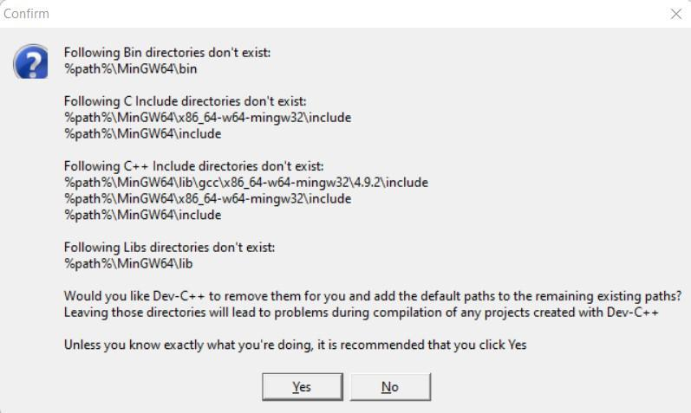
Note: We need to click ‘Yes’, Dev-C++ will automatically create the bins for us.
Dev-C++ IDE
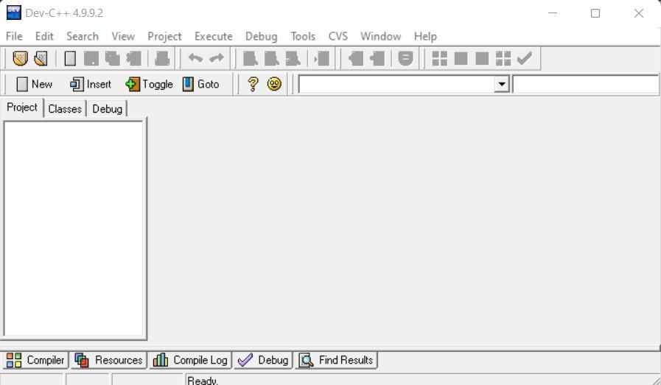

Lab 1.2 | Lab Tasks

- 1. First, review the algorithm in the box below, then respond to the questions.
repeat for (each person buying a burger)
enter the exact price of the burger
15% of the original price is multiplied to determine the reduction/discount.
The balance is determined by deducting the discount from the purchase price.
Print a bill with the purchase price, the discount, and the total amount owed.
end repeat

  - Which control structures are used in the algorithm?
    - Repetition or iteration and selection structures are used in algorithms. But Conditional structure is not frequently used in algorithms.
  - When the burger costs $21 what will the algorithm print?
    - Algorithm print with discounted price will be $17.85
  - How would you change the algorithm so that just the first 10 burger buyers may use it?
    - We can use an iteration or repetition structure for the first 10 burger buyers to start the loop and give discounted price to only first 10 buyers.
    - And apply condition to end the loop and discounted price after 10 person those firstly buy burger.
  - How would you change it such that the user may also enter the discount rate, which would then be used to calculate the discount?
    - By simply using Selection Structure of the control structure. User can change and enter the discount rate,which would then be used to calculate the discount

- Read in a number that shows the number of Hours. The output will convert this hour to minutes. 1 Hour = 60 minutes. Design an algorithm for the above problem.
  - The output will convert hours into minutes by simply using a formula as explained below:
let Hour = H and Minutes = M ;
then we can simply convert the Hours into Minutes by using a formula given below;
M = H * 60 ; >it is simply as : Minutes = Hours * 60

- Dr. Imran Usman is an instructor of the Computer Programing course. He wants to calculate the average marks of total students. Write an algorithm to calculate the average of student marks.
  - Here is the way how Dr Imran Usman can calculate the average of student marks in a algorithmic way :
    - Firstly Dr Imran has to define the total number of students like: “Enter total number of students = T”
      - Then he should define the total marks of total number of student like:”Marks of total number of students = N”.
        - Then we can find the average number of total students just by using a simple formula of average:
          - “Average Marks of Total Student = T/N ”
Here is how Dr Imran Usman can calculate the average marks of total students.

